**WMed**

# **Team**

# **Used Technologies**

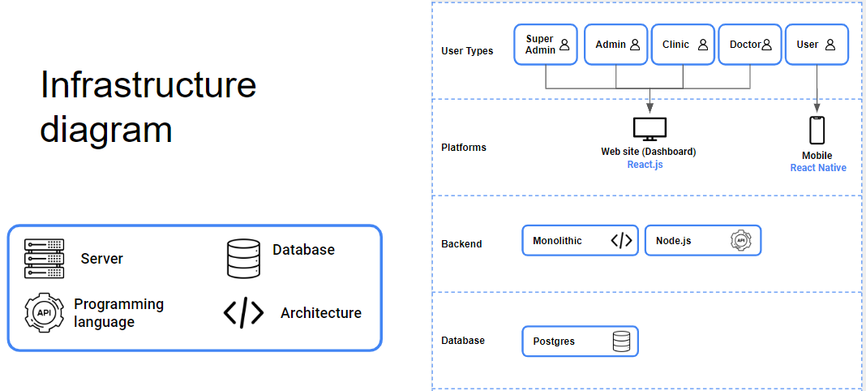

# **About**

Wmed (Wait Med) is a platform that allows users to not only book an appointment with a doctor online but also track their position in the queue in real time. Through this platform, users can spend their time productively on other tasks rather than waiting outside the doctor's office.

# **Goal**

By developing this platform, we aim to make that 6% of a person’s life more productive. According to statistics, if a person lives for 80 years and spends 1 hour waiting, they would have spent 5 years of their life waiting, which equals 6% of their lifetime.

**Addition**

Qualified doctors search service -Provides users with the opportunity to find reliable and qualified doctors faster. Services include providing full information and qualifications of doctors and thereby offering only the best services, rating them by evaluating doctors. In addition, users can receive advice by writing direct messages to doctors.

**Planned features**

* **Doctor AI** - through this app, users can receive doctor recommendations based on given symptoms, as well as answers to health-related questions that do not require a doctor's diagnosis. Additionally, they can access simple health knowledge and advice for home care.
* **Clinics** - The Clinics section allows users to get information about nearby clinics, schedule appointments with doctors, and view the list of services offered by the clinic.
* **Pharmacy** - The Pharmacy section allows users to search for medications and compare prices

# **System roles**

1. **Super Admin -** project owners and responsible for create admins
2. **Admin -**the people who create the clinics and the people responsible for the management party
3. **Clinic -** person in charge of one clinic. He is the person responsible for the creation of doctors and the full work of the clinic
4. **Doctor -** clinikada ishlaydigan doctor, o'zining profiliga masul inson.
5. **User -** Any patient taken on the platform is human.

# **Figma**

[Figma link](https://www.figma.com/design/eGcweyHEUNjY7voZgU6GaG/GChH?node-id=85-1725&t=GE92DAZMfE1R0EUQ-1)

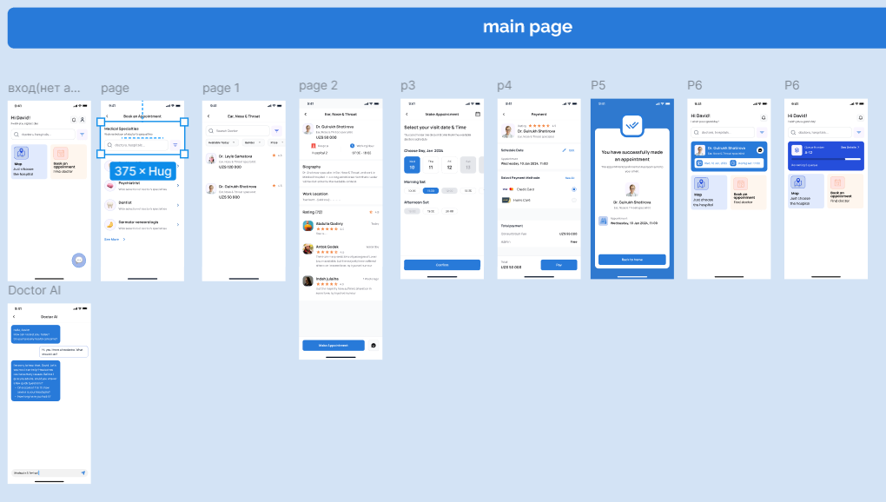

# **Conceptual model**

[Link to mindmap](https://xmind.ai/share/MLUr14bY?xid=OfyX8z5d)

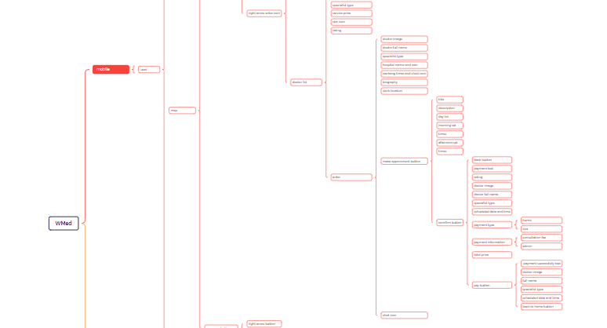

# **UML**

[Link to the uml](https://miro.com/app/board/uXjVLcEQHFM=/?share_link_id=270368007459)

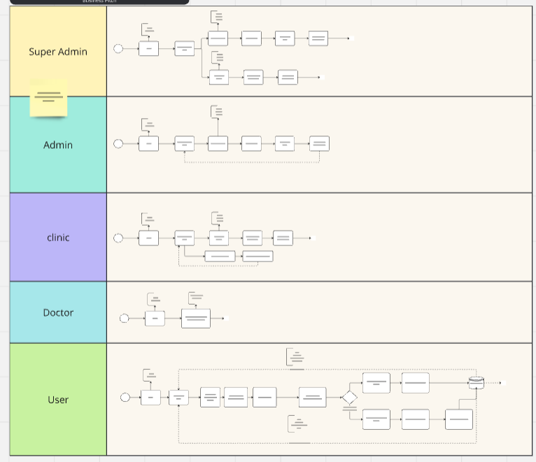

# **Integrations**

***Note*:** List integrations to be made to the project and will integrate to the MVP if time permits.

* AI - for Doctor AI section
* Google Map - to show users the location of clinics and pharmacy on a map
* OneId - for login part